**MSc Thesis Title**

by

Discipulus nomen

A Dissertation Submitted to the

Graduate School of Sciences and Engineering

in Partial Fulfillment of the Requirements for

the Degree of

Master of Science

in

Computer Science and Engineering



January 1, 2019

**MSc Thesis Title**

Koç University

Graduate School of Sciences and Engineering

This is to certify that I have examined this copy of a master’s thesis by

**Discipulus nomen**

and have found that it is complete and satisfactory in all respects,

and that any and all revisions required by the final

examining committee have been made.

Committee Members:

Prof. ABC (Advisor)

Assoc. Prof. XYZ [Co-Advisor]

Assist. Prof. MNO

Date:

*[Dedication here (Optional)]*

**ABSTRACT**

**MSc Thesis Title**

**Discipulus nomen**

**Master of Science in Computer Science and Engineering**

**January 1, 2019**

Abstract here. Abstract here. Abstract here. Abstract here. Abstract here. Abstract here. Abstract here. Abstract here. Abstract here. Abstract here. Abstract here. Abstract here. Abstract here. Abstract here. Abstract here. Abstract here. Abstract here. Abstract here. Abstract here. Abstract here. Abstract here. Abstract here. Abstract here. Abstract here. Abstract here. Abstract here. Abstract here. Abstract here. Abstract here. Abstract here. Abstract here. Abstract here. Abstract here. Abstract here. Abstract here. Abstract here. Abstract here. Abstract here. Abstract here. Abstract here. Abstract here. Abstract here. Abstract here. Abstract here. Abstract here. Abstract here. Abstract here. Abstract here.

**ÖZETÇE**

**Yüksek Lisans Tez Başlığı**

**Discipulus nomen**

**Bilgisayar Bilimleri ve Mühendisliği, Yüksek Lisans**

**1 Ocak 2019**

Özetçe burada. Özetçe burada. Özetçe burada. Özetçe burada. Özetçe burada. Özetçe burada. Özetçe burada. Özetçe burada. Özetçe burada. Özetçe burada. Özetçe burada. Özetçe burada. Özetçe burada. Özetçe burada. Özetçe burada. Özetçe burada. Özetçe burada. Özetçe burada. Özetçe burada. Özetçe burada. Özetçe burada. Özetçe burada. Özetçe burada. Özetçe burada. Özetçe burada. Özetçe burada. Özetçe burada. Özetçe burada. Özetçe burada. Özetçe burada. Özetçe burada. Özetçe burada. Özetçe burada. Özetçe burada. Özetçe burada.

**AKNOWLEDGEMENTS**

Acknowledgements here

**Table of Contents**

List of Tables iv

List of Figures iv

Abbreviations iv

Chapter 1: Introduction 4

Chapter 2: Format of The Thesis 4

2.1 Language 4

2.2 Paper Size and Page Layout 4

2.3 Font and Font Size 4

2.4 Pagination 4

2.5 Headings 4

2.6 Footnotes 4

2.7 Tables and Figures 4

2.8 Equations 4

2.9 Bibliography 4

2.10 Printing 4

Chapter 3: ……. 4

3.1 Section 4

3.1.1 Subsection 4

3.1.2 …… 4

3.2 …… 4

3.2.1 ……. 4

Chapter 4: Conclusion 4

Bibliography 4

Appendix A: ….. 4

# List of Tables

Table 2.1: Page layout margin information. 4

# List of Figures

Figure 2.1: Updating the table of content 4

Figure 2.2: Updating Lists of Tables and Figures 4

Figure 2.3: Insert caption for tables/figures 4

Figure 2.4: Insert reference to figure/table in text 4

Figure 2.5: Sample plots: (a) the first sample, (b) the second sample. 4

# Abbreviations

|  |  |
| --- | --- |
| ASM | Active Shape Model |
| DP | Dynamic Programming |
| PCA | Principal Component Analysis |
| RMSE | Root Mean Squared Error |
|  |  |
|  |  |
|  |  |
|  |  |

# Introduction

Start with an introduction.

# Format of The Thesis

## Language

The Thesis must be written English. A Turkish abstract must appear under Özetçe.

## Paper Size and Page Layout

International A4 size paper must be used. Paper must be of good quality and of sufficient opacity for normal reading (of weight 70 gr/m2 to 100 gr/m2). Only one side of the paper must be used.

The page layout should be single column with one and a half spacing used between the lines except the Abstract section. Single spacing should be used in the Abstract. All text pages should be justified. Page margins must comply with the following:

• Left margin: 35 mm from the edge of the paper

• Right margin: 25 mm from the edge of the paper

• Top margin: 25 mm from the edge of the paper

• Bottom margin: 25 mm from the edge of the paper

## Font and Font Size

Text must be typed in Times New Roman. Text font-size should be 12-point including equations, Table headings, Table and Figure captions. Footnotes, long biographical quotes and extensive quotations should be 10-point.

## Pagination

Each page in the thesis (except the first two title pages) is expected to have a page number. The preliminary section, including the title page; committee page; dedication or acknowledgments pages, if any; abstract pages; Table of Contents, List of Tables and Figures, and Nomenclature pages should be numbered, using lower case Roman numerals. The Roman numeral page numbers must be at the bottom center of the pages starting from the third page of the thesis. For the remainder of the thesis, pages must be numbered consecutively through the thesis, starting at the first page of the Introduction using Arabic numerals. The Arabic numeral page numbers must be at the top right side of the pages starting from the Introduction.

## Headings

Headings should be in Times New Roman. There may be at most four levels of headings which are chapter headings, section headings, first subsection headings and second subsection headings. Chapter headings must be centered, bold face, all capital and 14 pt. All section headings must be left adjusted, bold face and 12 pt. The section headings must be slanted, the first and second subsection headings must be italic, and the second subsection headings should not be numbered.

*2.5.1 First Subsection Heading*

There goes the first subsection...

*Second Subsection Heading*

There goes the second subsection...

You can use the modified word “Styles” in this template as follows:

Chapter headings => Heading 1

Section headings => Heading 2

First subsection headings => Heading 3

Second subsection headings => Heading 4

* When you insert a new chapter heading (Heading 1 style), the numbering system will automatically add the “Chapter #”, then you should add the chapter title on a new line by pressing (Enter + Shift), this ensures that the chapter number and its title will appear on the same line in the table of content.

* You can update the table of content by clicking on it, then clicking “Update table” option on the upper left corner and choose “update entire table” from the options. Check Figure *2*.*1*.

* You can update both lists of tables and figures by right clicking on the lists and choosing “update field” from the list. Check Figure 2.2.

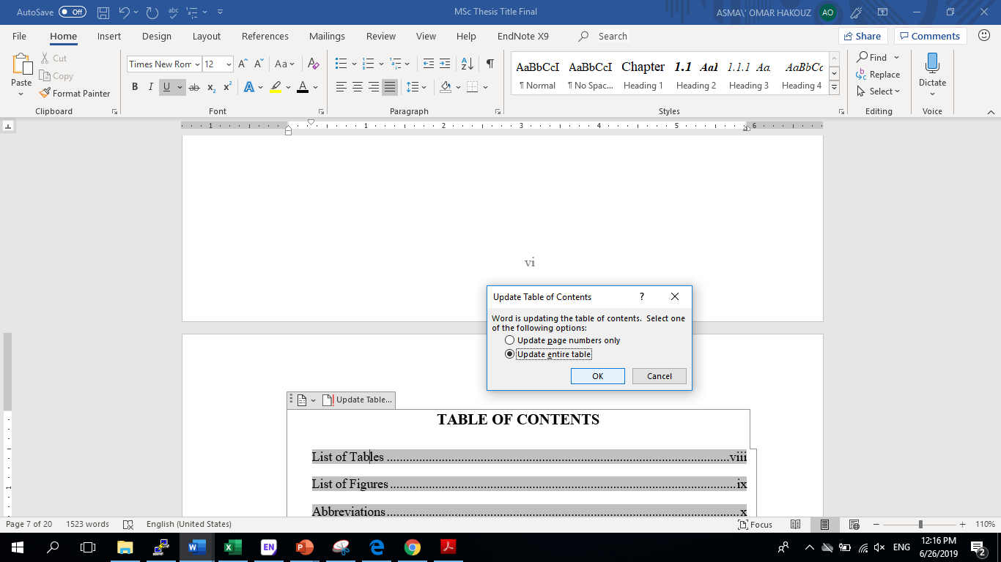

Figure 2.1: Updating the table of content

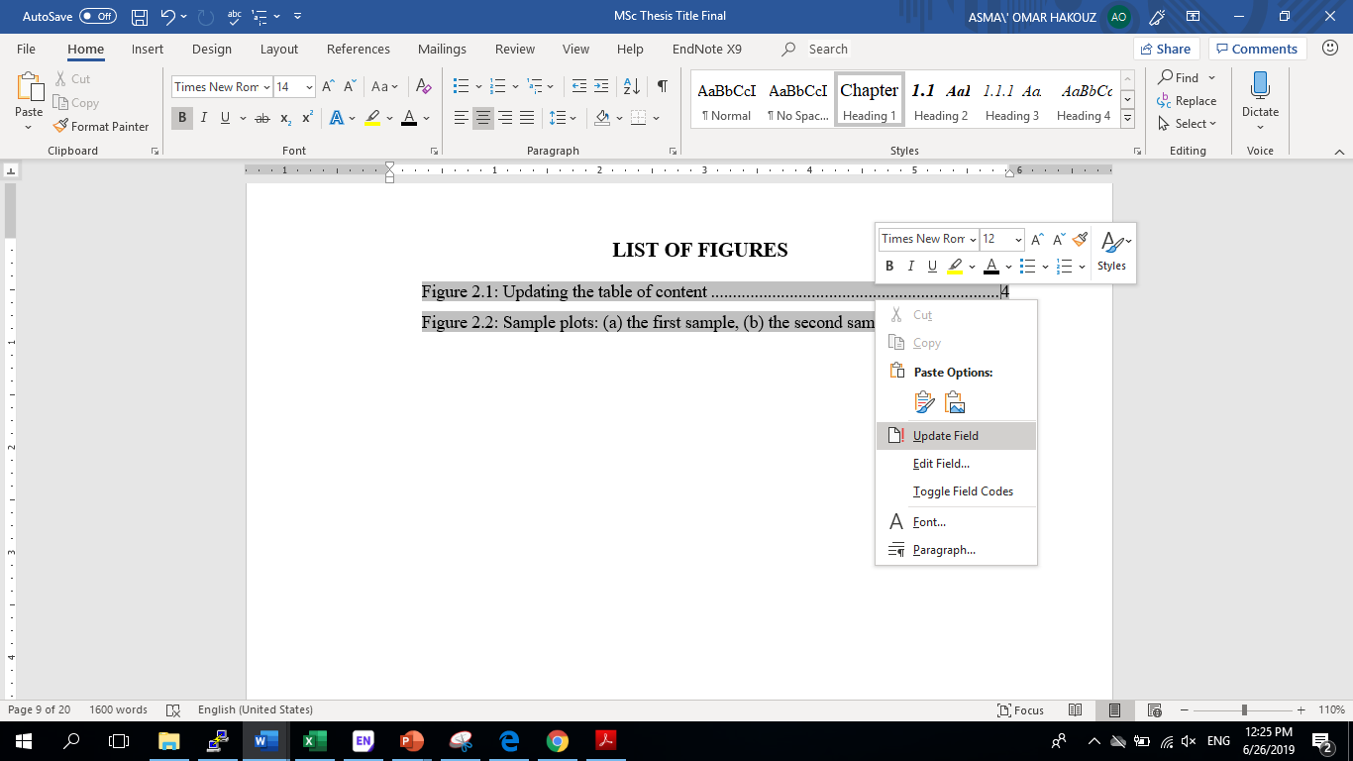

Figure 2.2: Updating Lists of Tables and Figures

## Footnotes

Recognizing that there are differences in disciplinary approaches, footnotes should still be used with discretion and when absolutely necessary. They should be placed at the bottom of the page on which they are indicated[1].

Table 2.1: Page layout margin information.

|  |  |
| --- | --- |
| Margin | Length from the edge of the paper (mm) |
| Left margin | 35 |
| Right margin | 25 |
| Top margin | 25 |
| Bottom margin | 25 |

## Tables and Figures

Tables and Figures should be enumerated within each chapter, i.e., as 1.1, 1.2, 1.3, 3.1, 3.2, etc. While referring to the tables and figures the first letter should be in capital (i.e, such as Table 2.1 or Figure 2.1). Sub-figures should be enumerated by adding the corresponding lowercase letter, such as Figure 3.1a. The sub-figures should not have captions, their information rather be included in the caption of the Figure.

Table captions should be located above the Tables whereas Figure captions should be placed below the Figures. All captions should end with a period.

* When you add a caption to a table or a figure you can select the table/figure, then right click on it and choose “Insert Caption”. Check Figure 2.3.

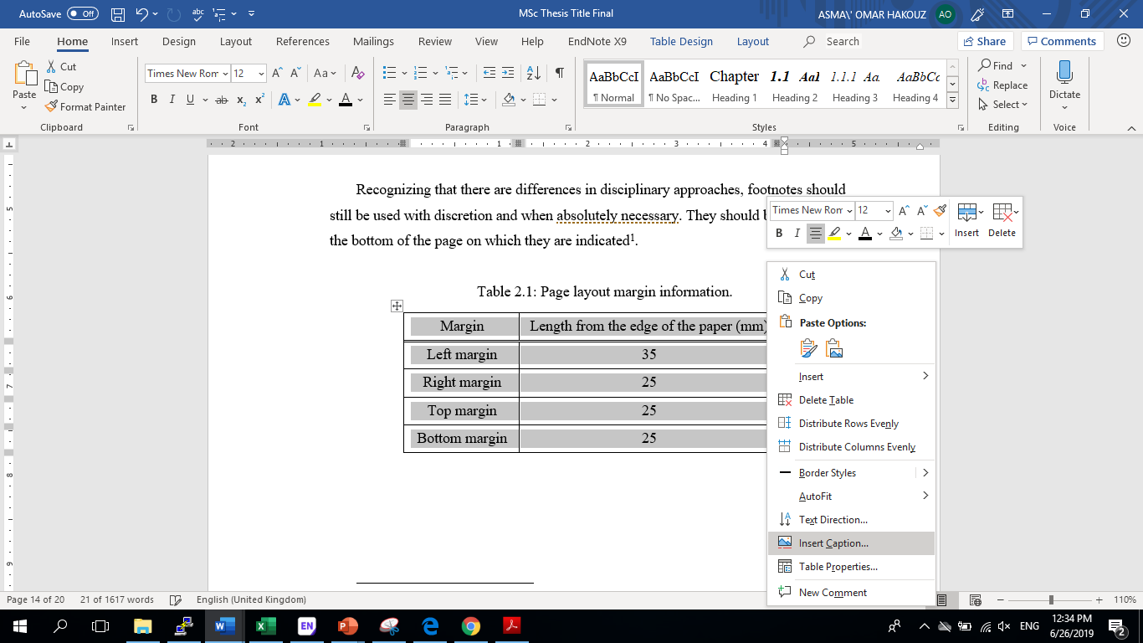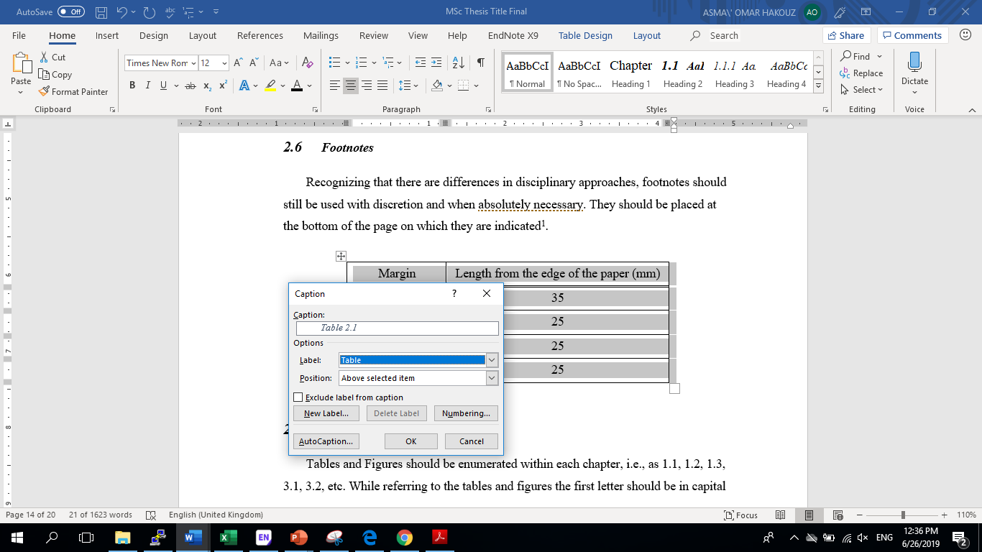

Figure 2.3: Insert caption for tables/figures

* To insert a reference to the table/figure in the text. You should go to References tab => Cross-reference and choose the table/figure you need to reference. Do not forget to pick “Only label and number” option. Check Figure 2.4.

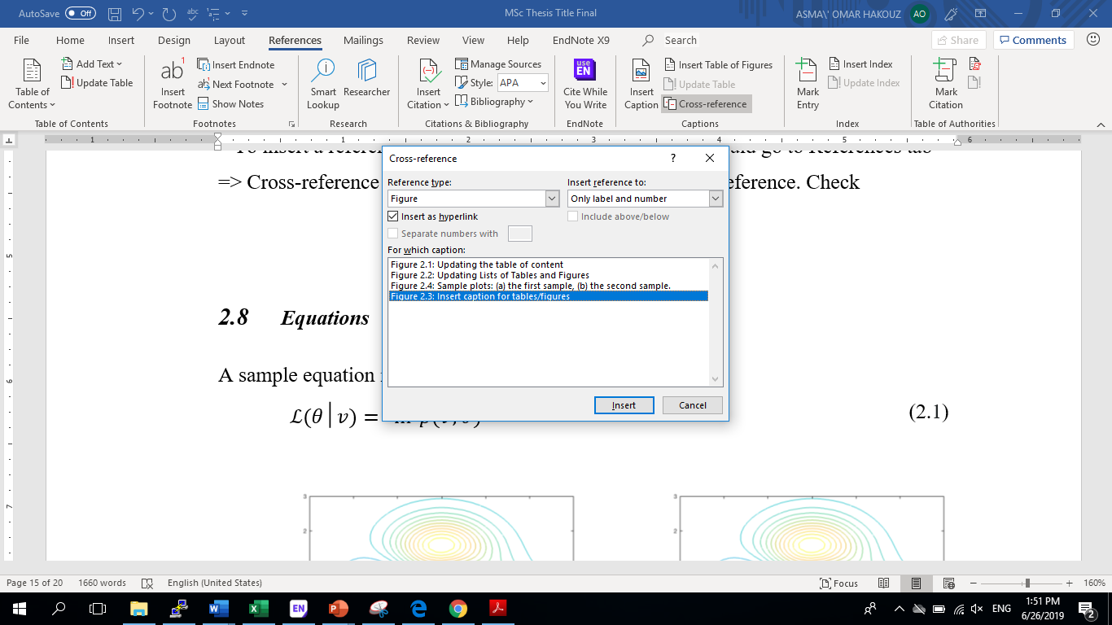

Figure 2.4: Insert reference to figure/table in text

## Equations

A sample equation is given as

|  |  |  |
| --- | --- | --- |
|  | $$L(θ│v)= ln⁡p(v;θ)$$ | (2.1) |

|  |  |
| --- | --- |
| (a) | (b) |

Figure 2.5: Sample plots: (a) the first sample, (b) the second sample.

Yet another aligned set of equations are given as

|  |  |  |
| --- | --- | --- |
|  | $$W=\left[\begin{matrix}\begin{matrix}w_{1,1} & w_{1,2} \\ w_{2,1} & w_{2,1}\end{matrix} & ⋯ & \begin{matrix}w_{1,H} \\ w_{2,H}\end{matrix} \\ ⋮ & ⋱ & ⋮ \\ \begin{matrix}w_{V,1} & w_{V,2}\end{matrix} & ⋯ & w_{V,H}\end{matrix}\right],$$ $Σ= \left[\begin{matrix}\begin{matrix}σ_{ 1}^{2} & 0 \\ 0 & {σ }_{2}^{2}\end{matrix} & ⋯ & \begin{matrix}0 \\ 0\end{matrix} \\ ⋮ & ⋱ & ⋮ \\ \begin{matrix}0 & 0\end{matrix} & ⋯ & σ_{ V}^{2}\end{matrix}\right]$. | (2.2) |

## Bibliography

It is important to follow a consistent citation usage throughout the thesis. Suggested citation usage follows the APA style (surname of the ﬁrst author, year) type. Usage for diﬀerent reference types are exempliﬁed in the following.

This is a sample journal reference with single author [Breazeal, 2003].

This is a sample conference reference with more than two authors [Zhang et al., 2004].

This is a sample book reference with two authors [Ekman and Friesen, 1975].

This is a sample PhD thesis reference [Cuartas, 2012].

This is a sample MS thesis reference [Krizhevsky, 2009].

This is a sample technical report reference [Roux and Bengio, 2007].

This is a sample web-page reference [GSSE, 2018].

* You can also use IEEE style as an alternative, as in the following example

This is a sample of an IEEE reference style [1]

## Printing

Note that the generated pdf ﬁles will have the designated page layout, however depending on which viewer and operating system that you are printing page layout might have modiﬁcations. The best suggested practice is to take the ﬁnal print directly on the printer through a memory stick.

# …….

## Section

### Subsection

### ……

## ……

### …….

# Conclusion

# Bibliography

[Breazeal, 2003] Breazeal, C. (2003). Toward sociable robots. Robotics and Autonomous Systems, 42(34):167 – 175.

[Cuartas, 2012] Cuartas, G. F. M. (2012). On the Expressive Power of Discrete Mixture Models, Restricted Boltzmann Machines, and Deep Belief Networks – A Unified Mathematical Treatment. PhD thesis, University of Leipzig.

[Ekman and Friesen, 1975] Ekman, P. and Friesen, W. (1975). Unmasking the Face: A Guide to Recognizing Emotions from Facial Clues. Spectrum books. PrenticeHall.

[GSSE, 2018] GSSE (2014 (accessed December 31, 2018)). Graduation checklist. https://gsse.ku.edu.tr/en/current-students/graduation-checklist/.

[Krizhevsky, 2009] Krizhevsky, A. (2009). Learning multiple layers of features from tiny images. Master’s thesis, University of Toronto.

[Roux and Bengio, 2007] Roux, N. L. and Bengio, Y. (2007). Representational power of Restricted Boltzmann Mchines and Deep Belief Networks. Technical report, Universite de Montreal.

[Zhang et al., 2004] Zhang, Z., Liu, Z., Sinclair, M., Acero, A., Deng, L., Droppo, J., Huang, X., and Zheng, Y. (2004). Multi-sensory microphones for robust speech detection, enhancement and recognition. In The International Conference on Acoustics, Speech, and Signal Processing, ICASSP, volume 3, pages 781–784.

**IEEE style example:**

[1] GSSE (2014 (accessed December 31, 2018)). Graduation checklist. https://gsse.ku.edu.tr/en/current-students/graduation-checklist/.

# Appendix A: …..

Appendix goes here.

1. A sample footnote.